Laptop Issuance Form

Employee Details
- Full Name: OMKAR UDANDE
- Designation: PYTHON DEVELOPER
- Employee ID: QS0022080
- Department: IT
- Date of Issue: 18/ 6/ 2025


Laptop Details
- Laptop Brand: DELL
- Model Number: 3Y983J3
- Serial Number: 3Y983J3
- Processor: I7 11th gen
- RAM: 16GB
- Hard Disk / SSD: 512 SSD
- Operating System: WINDOW

Additional Accessories Issued (if any):
- Charger Received
- Mouse Not Received
- Laptop Bag Received
- Diary Received
- Pen Received
- Keychain Received
- Bottle Received
- Mousepad Received
- Other (please specify): Id Card Received

Guidelines and Acknowledgment

I acknowledge that I have been provided with a laptop and accessories by the company for official use. I understand that it is my responsibility to use the laptop and accessories in a professional and secure manner.

Responsibilities:

- Data Protection: I will ensure that all company data is stored securely and in accordance with company policies.

- Software Updates: I will regularly update the laptop's operating system, antivirus software, and other applications to ensure they are current and secure.


- Secure Connection: I will use company-approved VPN connections when accessing company resources remotely.

- Password Protection: I will keep the laptop and all company data password- protected and secure.

- Remote Wipe: I understand that the company may remotely wipe the laptop in case of loss, theft, or termination of employment.

- Usage Monitoring: I understand that the company may monitor laptop usage to ensure compliance with company policies.

- Return of Accessories: I will return all company-provided accessories, including chargers, mice, and laptop bags, upon resignation/termination or as instructed by the company.

- Damage Reporting: I will report any damage or issues with the laptop to the IT/HR department promptly, including any spills, drops, or other incidents that may affect the laptop's functionality.

- Company Property: I understand that the laptop and all accessories remain the property of the company at all times.

- Compliance with Company Policies: I will comply with all company policies and procedures related to laptop usage, data security, and confidentiality.

Liability and Cost Recovery:

1. I am responsible for the care and proper use of the laptop.

- I will not install unauthorized software or share company data.

- In case of damage, loss, or theft, I will report it immediately to the IT/HR department.

- I will return the laptop and all accessories in good working condition upon resignation/termination or as instructed by the company.

- I understand that misuse of the laptop may lead to disciplinary action.


- Damage Liability: I understand that if the laptop or any accessories are damaged, lost, or stolen due to my negligence or misuse, I will be liable for the costs of repair or

replacement, as determined by the company.

- Cost Recovery: The company reserves the right to recover the costs of any damages or losses from me, including but not limited to:
  - Repair or replacement costs for damaged or lost laptops and accessories
  - Costs associated with data recovery or breach mitigation
  - Any other costs incurred by the company as a result of my negligence or misuse.

- I will be responsible for paying the costs of damages or losses within the timeframe specified by the company.

Acknowledgment:

By signing below, I acknowledge that I have read, understood, and agree to comply with the guidelines and acknowledgments outlined above.

Employee Signature: 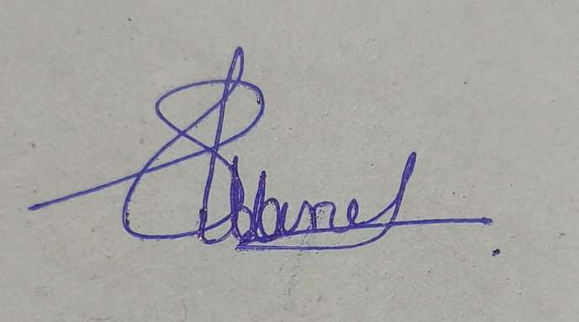 Date: 02 / 07 / 2025
HR/IT Representative Signature:

